**KING FAHD UNIVERSITY OF PETROLEUM AND MINERALS-DEPARTMENT OF PHYSICS**

**PHYS 441-221**

**QUIZ # 6 Solutions**

**Full answers taken directly from indicated page(s) of textbook (yours need not be as detailed)**

1. **Name the reason weak interactions are weak**

**Answer: page 315**



1. **Why is the weak interaction vertex of the form $γ^{μ}\left(1-γ^{5}\right)$, i.e. V-A type?**

**Answer: pages 308-309, see also comments at bottom of page 309**



1. **What is the lifetime of the muon, approximately?**

**Answer: page XIII ( $μs$ is ok for correct answer)**



1. **Which conservation law causes the decay $π^{-}→e^{-}+{\overline{υ}}_{e}$ to be suppressed compared to the decay $π^{-}→μ^{-}+{\overline{υ}}_{μ}$**

**Answer: pages 323-324**





1. **What is the value of the Cabibbo angle, approximately?**

**Answer: page 325**

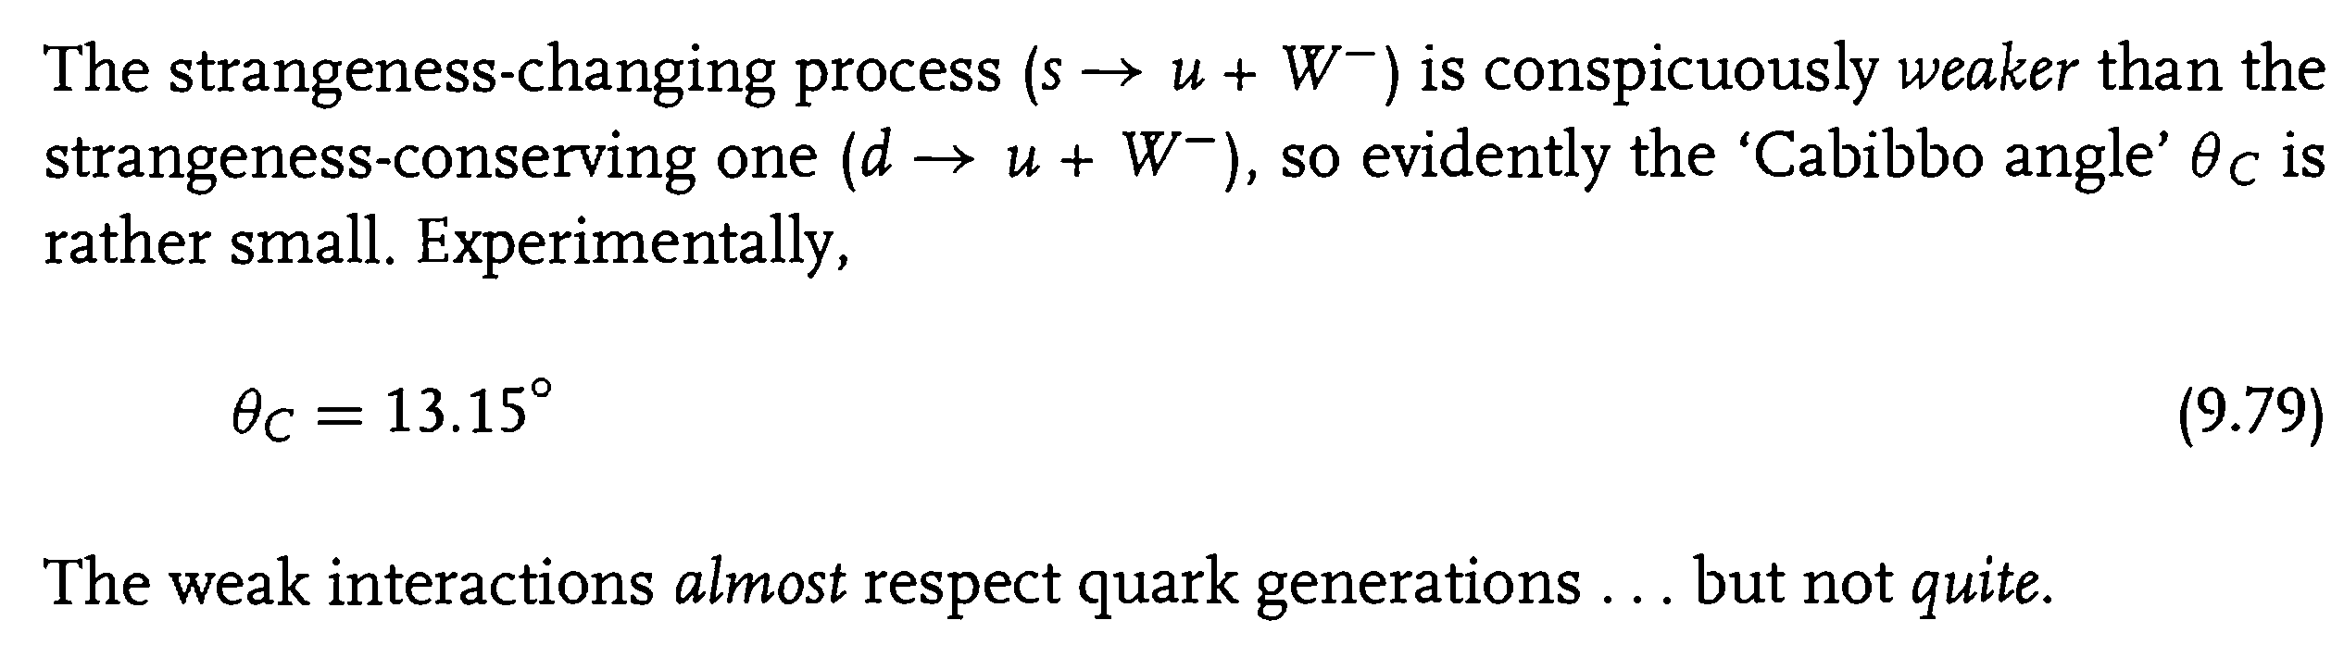

1. **Which quark was predicted to exist by the GIM mechanism?**

**Answer: pages 326-327**

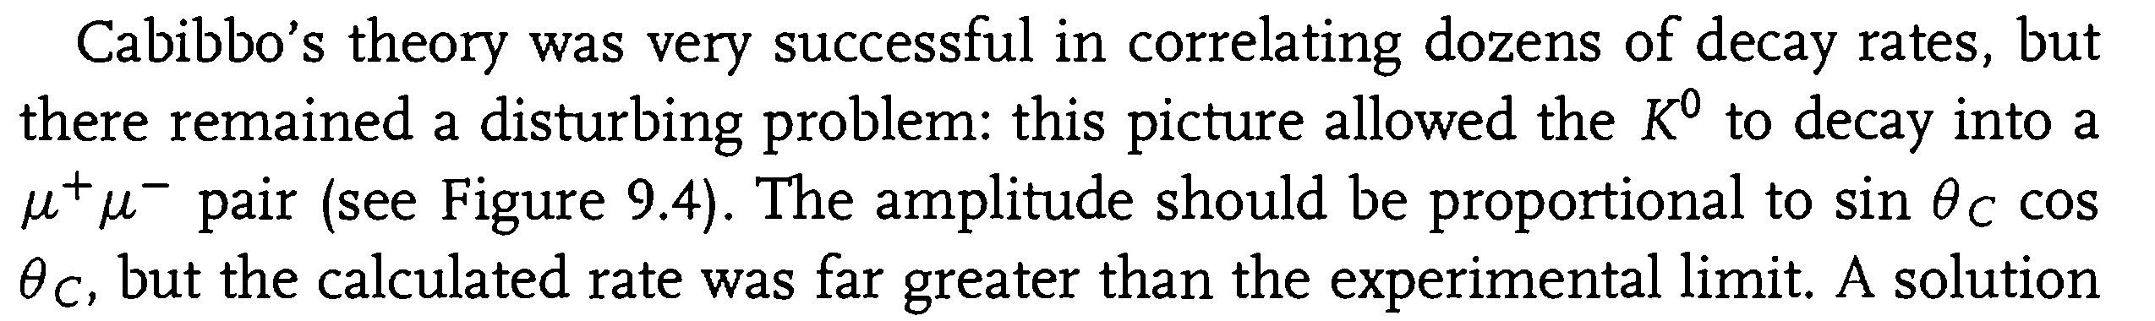



1. **Which quarks were predicted to exist by Kobayashi and Maskawa?**

**Answer: page 328**

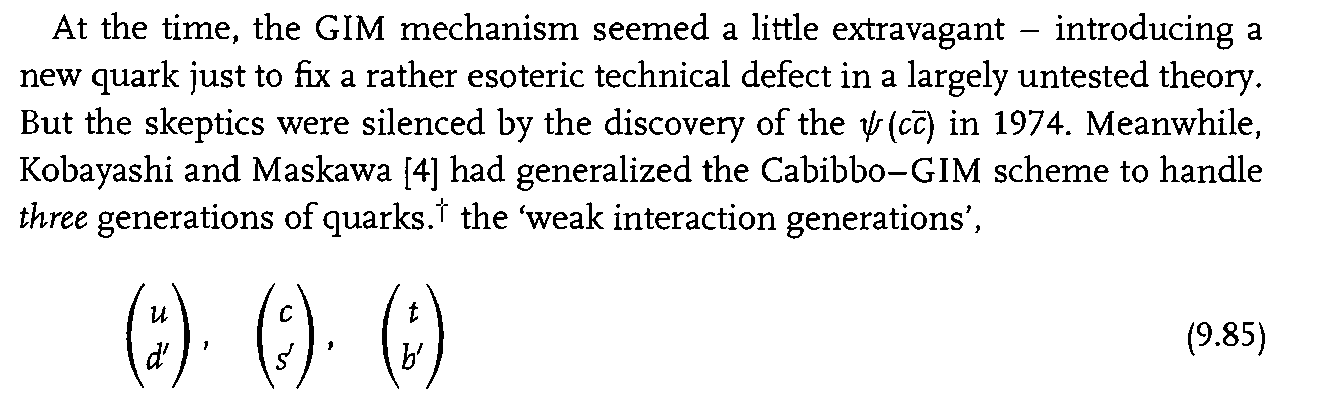

1. **What is the value of $\sin^{2}\left(θ_{W}\right)$, approximately? $θ_{W}$ is the weak mixing angle.**

**Answer: page 332**

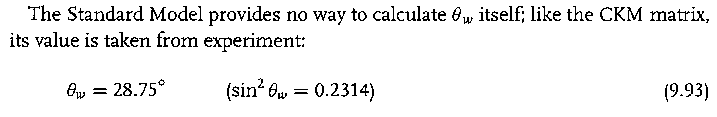

1. **What type of scattering was used/observed to prove the existence of neutral weak currents? When and Where?**

**Answer: page 330-331**



1. **When and where were the 3 weak vector bosons discovered? What were their masses?**

**Answer: page 332**

